Select sum(total_price) as total_sales from pizza_sales_excel_file

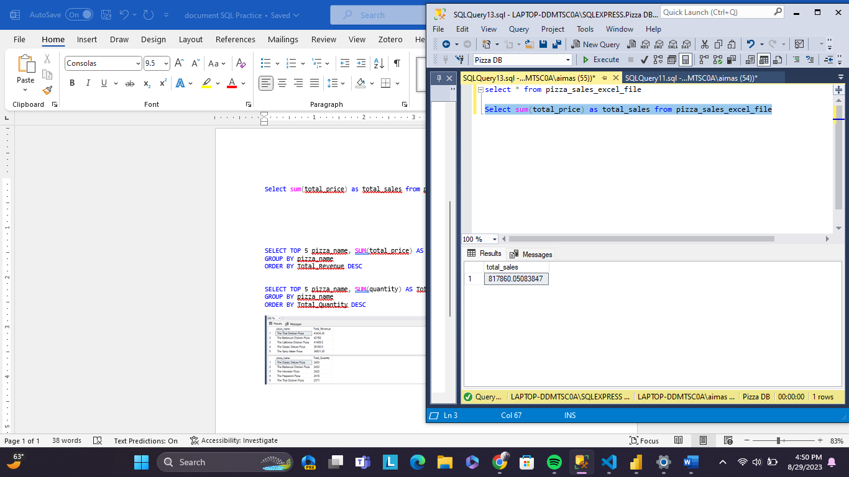

select sum(total_price) / count(distinct order_id) As Average from pizza_sales_excel_file

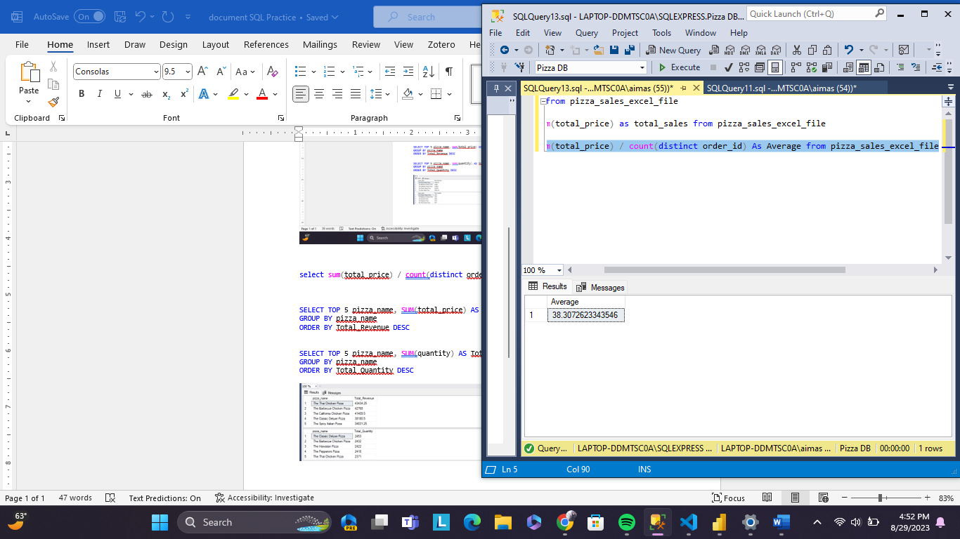

select sum(quantity) as total_pizza_sold from pizza_sales_excel_file

select count(distinct order_id) as total_orders from pizza_sales_excel_file

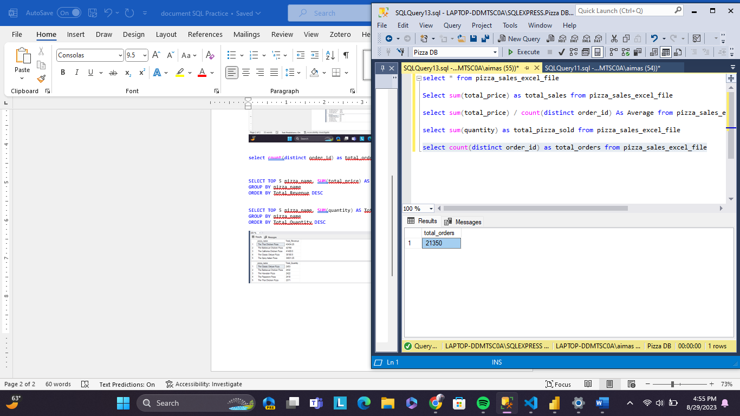

select CAST (CAST(sum(quantity) AS DECIMAL (10,2 ))/ CAST (count(distinct order_id) AS DECIMAL (10,2)) AS DECIMAL (10,2)) AS Avg_Pizza_Per_Order from pizza_sales_excel_file

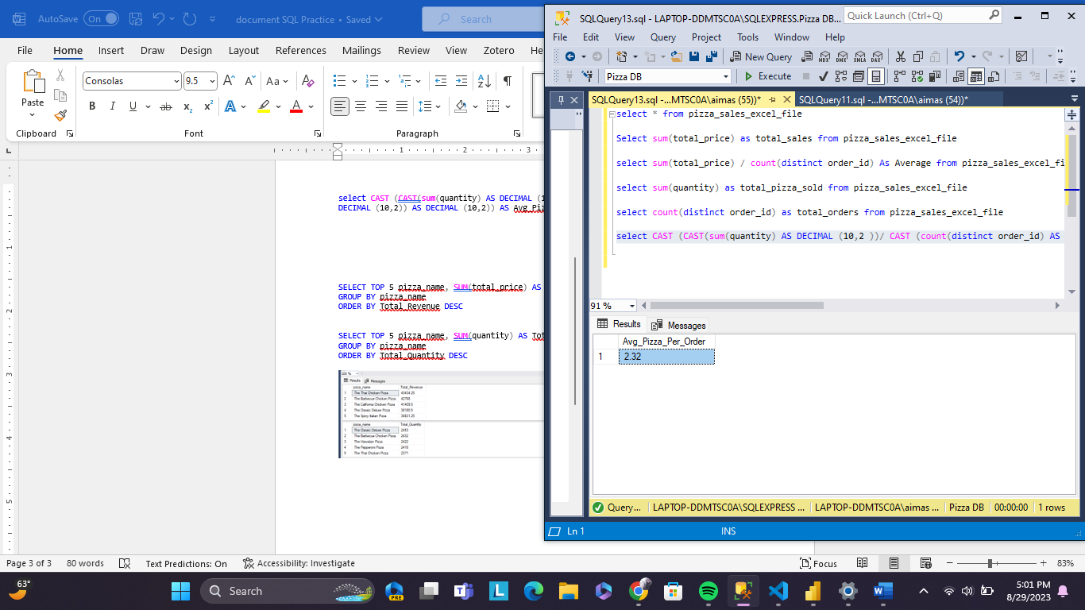

select DATENAME(DW, order_date) as order_day, count(distinct order_id) as Total_orders from pizza_sales_excel_file

GROUP BY DATENAME(DW,order_date)

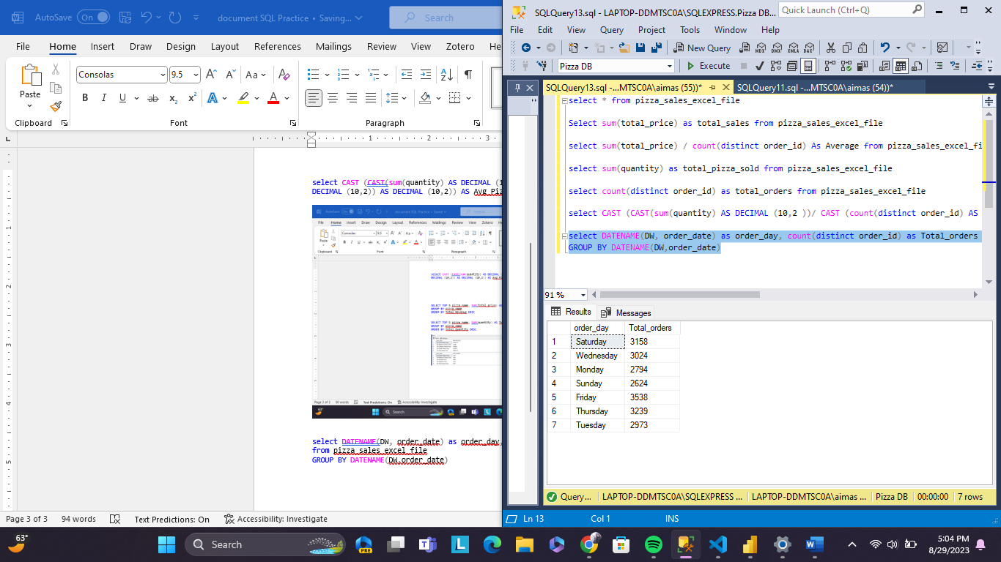

select DATENAME(MONTH , order_date) AS Month_Name, COUNT(distinct order_id) as Total_Orders from pizza_sales_excel_file

group by datename(month, order_date)

select pizza_category, sum(total_price) * 100 / (select sum(total_price) from pizza_sales_excel_file) AS PCT

from pizza_sales_excel_file

GROUP BY pizza_category

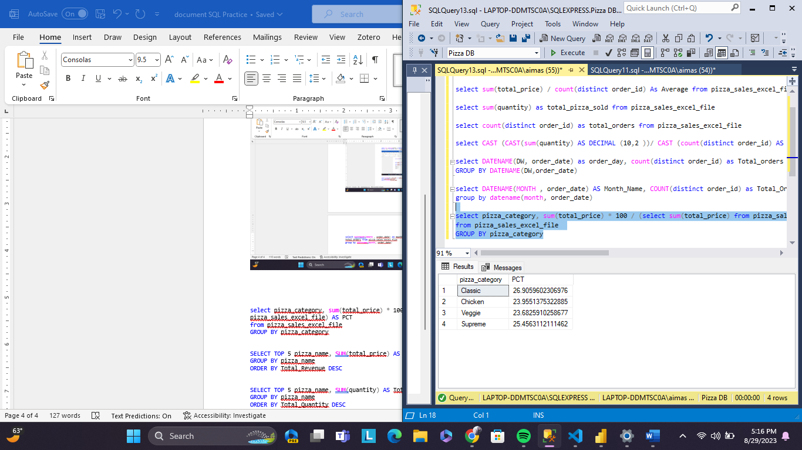

select pizza_size, sum(total_price) * 100 / (select sum(total_price) from pizza_sales_excel_file) AS PCT

from pizza_sales_excel_file

GROUP BY pizza_size

ORDER BY PCT DESC

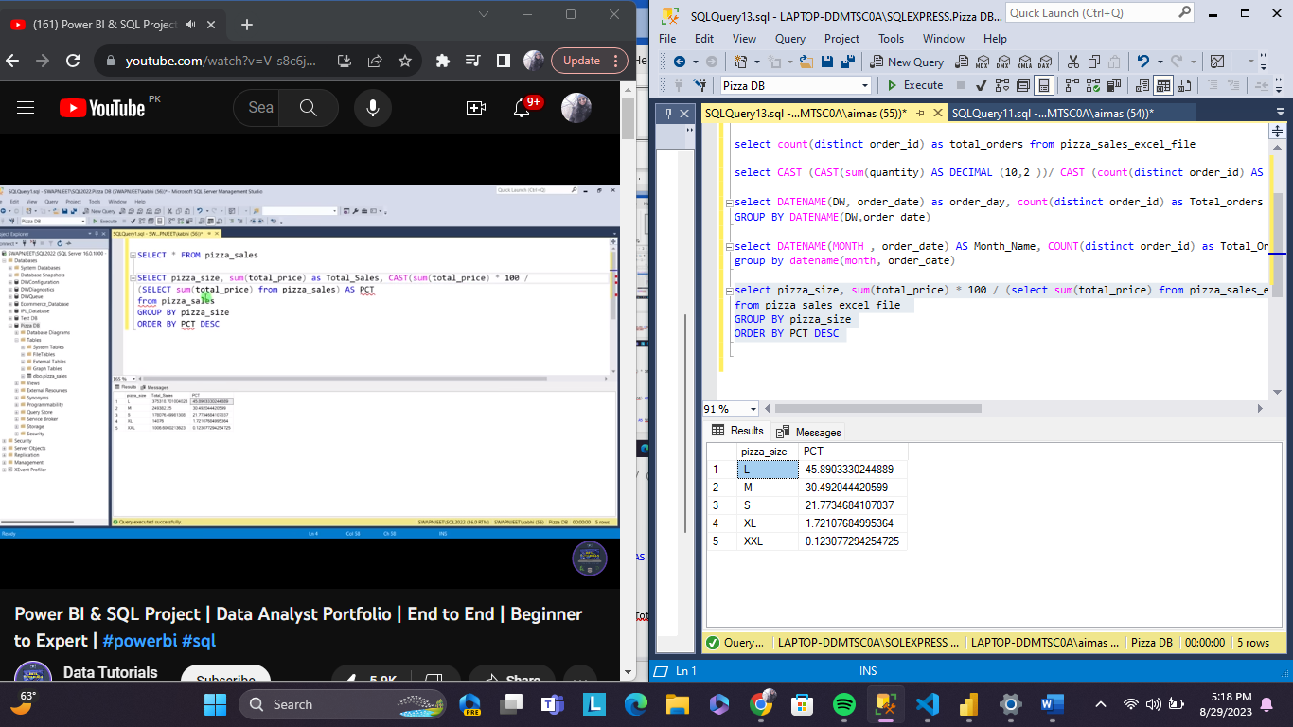

SELECT TOP 5 pizza_name, SUM(total_price) AS Total_Revenue FROM pizza_sales_excel_file

GROUP BY pizza_name

ORDER BY Total_Revenue DESC

SELECT TOP 5 pizza_name, SUM(quantity) AS Total_Quantity FROM pizza_sales_excel_file

GROUP BY pizza_name

ORDER BY Total_Quantity DESC

